**SQL Project:**

**Question#1:**

Write SQL statements to create the Employee and Department table.

**Employee Table:**

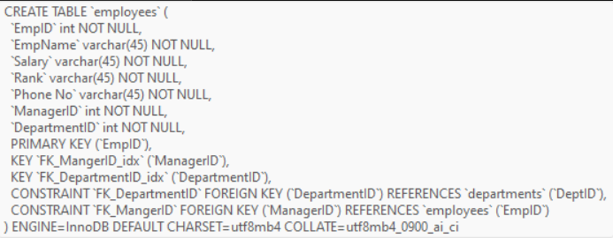

**Department table:**



**Question#2:**

Insert the sample data at least 5-Employees and 3-Departments in the relevant tables. Make sure the data of the employee is about your instructors in this Data Analytics batch and include yourself also as ‘Student’.  As for the managerID,  use any instructor as your manager and all instructors must have Sir Zeeshan Saleem as Manager. While Sir Zeeshan has no manager.

**Insert values into the employee table:**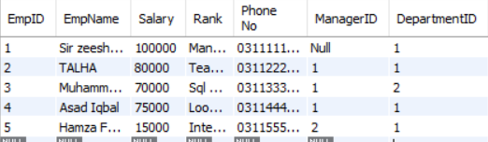

**Insert values into the Department table:**

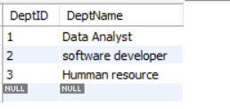

**Question#3:**

Write a SQL query to get Employee name, Department Name, Manager Name using Joins.

**Query:**

SELECT

employees.EmpName AS Employee_Name,

departments.DeptName AS Department_Name,

m.EmpName AS Manager_Name

FROM

employees

JOIN

departments ON employees.DepartmentID = departments.DeptID

LEFT JOIN

employees m ON employees.ManagerID = m.EmpID;

**Output:**

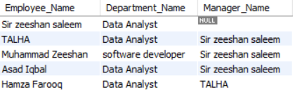

**Question#4:**

**Write an SQL query to sum the salary for each department using the SUM function and the GROUP BY clause.**

**Query:**

SELECT

departments.DeptName,

SUM(employees.Salary) AS Total_Salary

FROM

employees

JOIN

departments ON employees.DepartmentID = departments.DeptID

GROUP BY

departments.DeptName;

**Output:**

